|  |  |  |  |  |
| --- | --- | --- | --- | --- |
| **Headteacher :** Mr Stephen Jefferson  **Tel :** 01229 824210  **Email :** [info@chetwynde.cumbria.sch.uk](mailto:info@chetwynde.cumbria.sch.uk)  **Website :** www.chetwynde.co.uk | Chetwynde Logo_NARROW | Chetwynde School  Croslands, Rating Lane,  Barrow-in-Furness,  Cumbria, LA13 0NY | | |
|  |  | |  |

1st April 2021

Dear Parent/Guardian

**End of Spring Term Letter**

I write to you at the end of a very busy and productive return to school.

It was a great pleasure for all staff to see the pupils return from the 8th March and the testing went very smoothly.

Please could I remind parents to ensure that senior pupils continue to test over the Easter holidays, on a Sunday and a Wednesday. Please email [info@chetwynde.cumbria.sch.uk](mailto:info@chetwynde.cumbria.sch.uk) if your child receives a positive result.

**Ofsted**

I would like to take this opportunity to thank all those parents who took the time to complete the online survey and provide such supportive and constructive feedback about the school. Our overall feedback from Inspectors was very positive. They talked at length about the excellent feedback from staff, pupils and parents.

We will receive our written feedback from Ofsted within 30 days of the Inspection.

**Summer Term**

I am looking forward to the summer term. Work will continue on teaching and learning, catch up interventions and assessments for pupils in Years 7 - 10. Year 11 will sit their mock exams week beginning 26th April, and their leaving date will be Friday 28th May (more information will follow).

We will also be working hard to ensure our final transition to the South Cumbria Multi Academy Trust goes smoothly to start in September 2021.

**Key Dates**

* Summer term begins : Tuesday 20th April
* Bank Holiday : Monday 3rd May
* May Half Term : Monday 31st May – Friday 4th June
* End of Summer Term : Friday 9th July (noon)

I wish you all a happy, safe and restful Easter break.

Yours sincerely

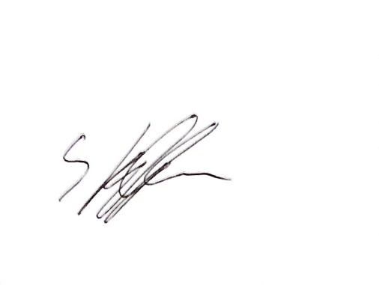

Mr S. Jefferson

**Headteacher**